OCE/Macro Dpt.
Macroeconomic-fiscal modeling & quarterly outlook – progress (outline key points)
Quarterly Macro Fiscal Model (QMFM)
Overview and rationale
Since mid-2022, the OCE team has developed and fully implemented a quarterly macro-fiscal model FPAS-type gap-model of international standard with technical support from OGResearch (thru GIZ).
The QMFM allows producing a quarterly macro-fiscal outlook (16 quarters ahead) and summary forecast presentations which reflect fiscal policy (deficit, govt spending and demand), monetary and exchange rate policy (rules), and judgmental near-term forecasts (e.g., this quarter’s CPI, next quarter’s GDP,…).
It allows simulating the macro effects of alternative macro policies, of shocks (e.g. international prices, domestic food supply, energy price shocks, …) and policy responses, and of changes in longer-term trends (e.g. potential output, neutral and real interest rate, RER depreciation).
The results provide inputs for intMF projections for variables that are otherwise “set”, sometimes by NBR or projected judgmentally or residually: GDP, CPI, ER, consumption, investment. And overall consistency checks for intMF macro aggregates (e.g., ex/imports, deflators, dom/ext. debt, savings….)
The key outcomes are improved intMF projections; OCE QMFO; deepened staff understanding of macroeconomics and complex interactions; and enhanced coordination with NBR.
Design and appropriation process
Pilot and initial training round in Matlab in online sessions with OGR April-June 2021
New OCE team (incl. GIZ Research Fellows) from April 2022, 4-5 staff (incl. one RF)
Five 1½ week workshops of hands-on training and exercises from Oct 2022 to Dec 2023 with OGR:
Refreshment of economic theory underlying the model (esp. DSGE, role expectations)
Adaptation of QMFM to Rwanda economy & data and MINECOFIN’s needs
Further training in Matlab, data management, and macro modeling (IRIS)
Refreshment in econometrics (filters), (Bayesian) estimation, and model calibration (parameter choice)
Joint development of fiscal block: deficit, revenue, govt demand for G&S, other spending,
of financing/debt block: financial flows, grants, and debt
Producing forecasts, simulations with policies or exogenous shocks etc. tuned
Pilot Quarterly Economic-Fiscal Outlook and Forecast presentations in January, April, and June 2023
Exchange and discussion with NBR macro modeling team.
Distinctive features model
The distinctive features compared to other such models as used by CBs are:
-elaborated fiscal block (incl. deficit components (deficit, government demand and revenue and finacing) over the business cycle and discretionary fiscal policies (other expenditures incl. transfers and subsides….)
-breakdown of final demand into components (consumption, govt demand, investment, exports, imports) which allows the model to extract and distinctly diagnose their shocks to economic indicators
-derivation of key macro variables in levels and real/nominal terms allowing comparison with, and provision of inputs for, other macroeconomic projections tools.
Anchored on data from macroeconomic framework
Linked to Integrated Macroeconomic Framework (intMF) and its source data (NBR, NISR NA, NISR CPI details, debtDG, latest WEO,
Using all available recent information and near-term forecasts, judgments on output, inflation, interest and exchange rates (for current and next few quarters)
Uses now/forecasting tool for current/next quarter real GDP
Complementary to and providing inputs into intMF projections
intMF is accounting framework not model; supply-driven (sum of sector projections), mostly exogenous; CPI and other prices, ER, are targets, exogenous; no impact of demand on output; private investment ‘set’, consumption residual
QMFM full macro business cycle model: demand-driven (sum of FD) determining output level vis-a-vis potential or trend output; captures impact of government demand and fiscal policy on demand and output; prices, exchange rate and interest rates are endogenous, simultaneously determined with outputs and final demands
QMFM forecasts are fed into intMF, in consultation with NBR which has similar model but without fiscal block: CPI, ER, output (adjustments to sector forecasts), consumption, investment
Model value addition to IntMF analysis and IMF Mission discussion:
Effect of fiscal policies on economy (Real GDP growth and Inflation): Model fiscal structure/feature allows to analyze/diagnose and capture the multiplier effect of fiscal policies (i.e., direct effect of government demand-public consumption & investment and indirect effect (fiscal impulse) of other expenditures-transfers, subsidies and net lending) to the business cycle (output gap and inflation)
Through Quarterly forecasting fiscal indicators: model uses inputs of IntMF or PCI program (i.e., fiscal deficit path agreed with IMF) and quarterly semester information of government spending (i.e., quarterly treasure committee planned spending and interest payments) to give a consistent outlook on deficit, government demand and revenue in a period of 8 quarters ahead
Model forecast/outlook can be used as inputs to the forward looking macroeconomic analysis: forecast of interest rates, inflation and exchange rates and GDP can be useful inputs to IntMF (i.e., real, fiscal and BOP)
Illustrative forecast output
Selected forecast charts (GDP, output gap; fiscal; final demands; inflation; RIR, RE)—results also include
tables incl. Annualized quarterly forecasts table (main indicators) for comparison with intMF variables

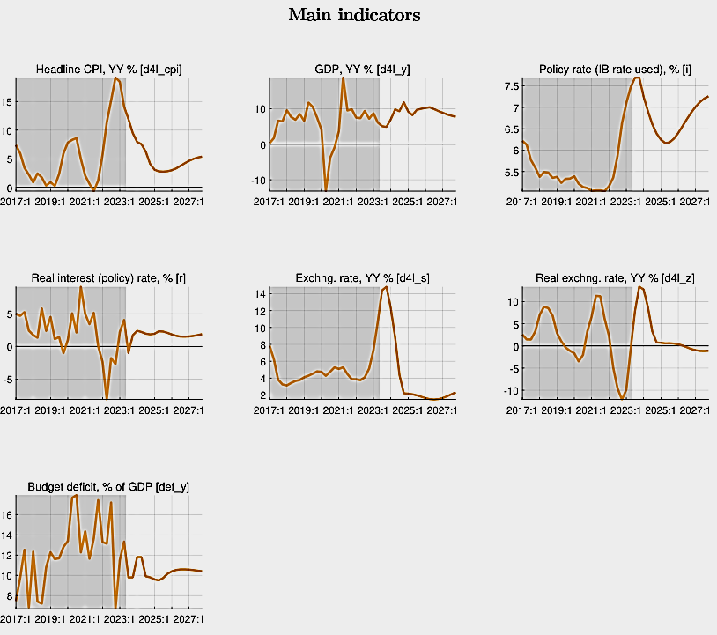
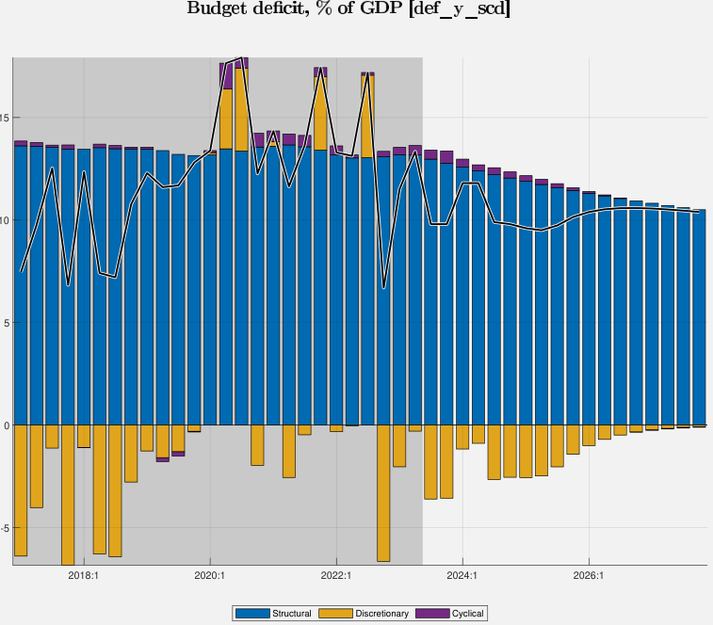
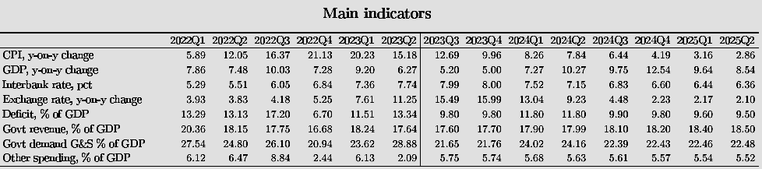

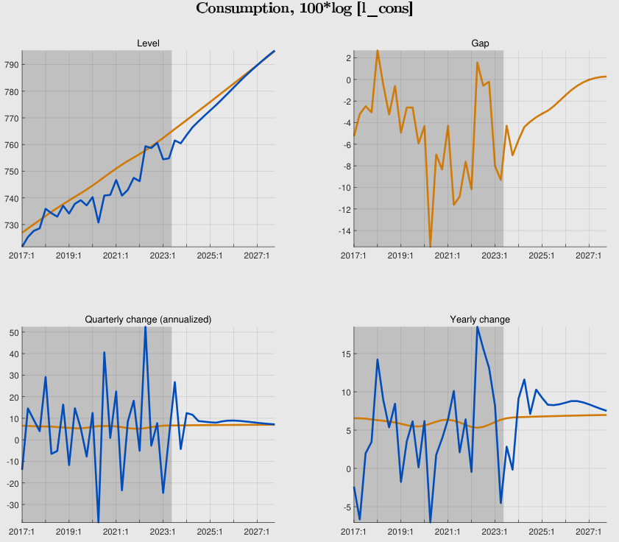
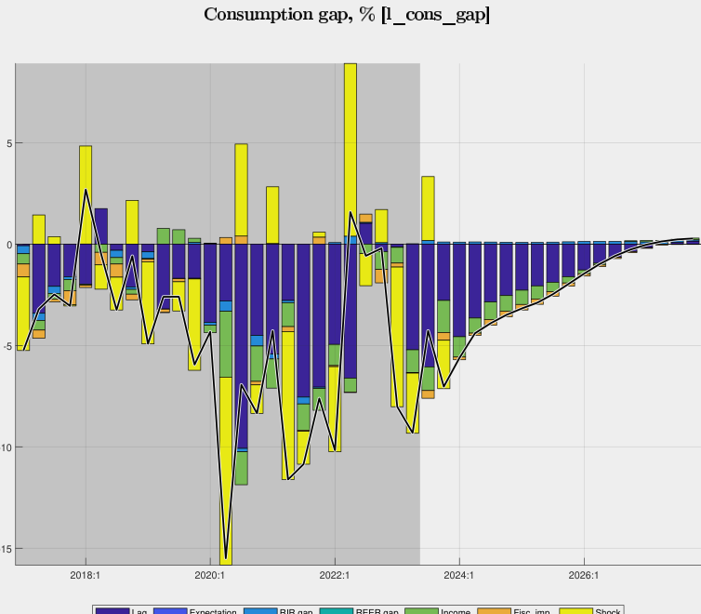
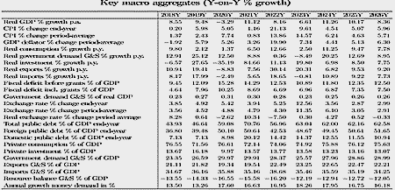

Flow chart model (transmission channel chart?)
Next steps and agenda
Finalization of this round’s Quarterly Economic-Fiscal Outlook (report)—Jan
Draft Executive Forecast Presentation (ppt) and review process—Dec
Forecast presentation—Jan
Assignment tasks within team, based on new structure MPDG
At least quarterly update/improvement QMFM and intMF, results discussed in sessions with
NBR, NISR,..

Forecasting Policy Analysis System (FPAS) is a macro modeling approach used by central banks for Inflation Targeting (IT). NBR developed and implemented its FPAS during 2011-20 (NBR Economic Review, 2014, 2015, 2018 and IMF/NBR WP, 2014, 2020).

